Web Application Penetration Testing Report
Organization: ECLLLLLLL2
Document Timestamp
Version | Issued by | Reviewed by | Issued Date
1.0 | Krishna Gupta | Indrakant Chaubey | 15-07-2026

Table of Contents
Right-click here and choose “Update Field” (or press F9) to generate the Table of Contents.

1. Document Control

1.1 Document Approvers
The individuals who reviewed, verified and approved the content of this document based on the requirements of the defined services during this document's creation are listed in the table below:
Approver Name | Approver Designation | Date Content was Approved
Derrick Anthony | Manager - Cyber Security | 15-07-2026

1.2 Amendment Record
The following Change History log contains a record of changes made to this document.
Version | Issuer | Section / Nature of Change | Published/Revised Date
1.0 | Krishna Gupta | Initial VAPT | 15-07-2026

2. Executive Summary

2.1 Scope of Testing
The following URLs were in scope and included in this assessment:
Sr. No. | Application Name | Tested URL | Tested Environment | Testing Methodology
1 | Application | https://example.com | PROD | BlackBox

2.2 Milestone
Milestone / Deliverable | Date
VAPT Initiation | 15-07-2026
VAPT Completion | 15-07-2026

2.3 Risk Classification
Critical Risk | These vulnerabilities can allow attackers to take complete control of your web applications and web servers. In exploiting this type of vulnerability, attackers could carry out a range of malicious acts.
High Risk | A High severity vulnerability, which means that on exploiting such vulnerabilities, attackers can view information about your system that helps them find or exploit other vulnerabilities that enable them to access sensitive user and administrator information.
Medium Risk | Potential weakness in controls, which could develop into an exposure. Or issues that represent areas of concern and may impact controls. They should be addressed reasonably promptly.
Low Risk | Potential weaknesses in controls, which in combination with other weaknesses can develop into exposure. Suggested improvements not immediately/directly affecting controls.
Informational Risk | Weaknesses mentioned under these sections are informational and are best practices. Either these weaknesses cannot be exploited directly or are very difficult to exploit due to multiple constraints.

3. Summary of Findings
This section lists and bifurcates the total number of vulnerabilities reported, based on risk level.
The vulnerability assessment and penetration testing were performed on ECLLLLLLL2 applications. The test revealed 1 Low, 1 Informational vulnerabilities on the scope items. We recommend implementing the measures suggested for mitigation for each finding to improve the security posture of the affected systems.
Critical | High | Medium | Low | Informational | Total
0 | 0 | 0 | 1 | 1 | 2

4. Vulnerability Analysis & Findings

4.1 Vulnerability Overview
Sr. No | Vulnerability | Severity | CWE/CVE | Status
1 | Misconfigured CSP Header | Low | CVE‑2024‑29184 | Open
2 | Misconfigured CSP Header | Informational | CVE‑2024‑29184 | Open

4.2 Detailed Findings

4.2.1 Misconfigured CSP Header
Severity Level: Low
Status: Open
CVE/CWE: CVE‑2024‑29184
Description: During the assessment, it was observed that CSP is using unsafe eval and unsafe inline.
Business Impact: Using unsafe-eval and unsafe-inline in CSP lets attackers run harmful scripts easily. This can lead to Cross-Site Scripting (XSS) attacks and steal user data. It weakens browser protections meant to keep the website safe.
Vulnerable URLs: asdfghjklkjhgfdsdfghjk
POC1: no sensitive 1
POC2: no sensitive 2
Remediation: 1. Remove 'unsafe-inline' and 'unsafe-eval' from script-src.
2. Use CSP nonce or hashes for inline scripts.
3. Avoid wildcard sources (*) in directives.
Reference: https://cheatsheetseries.owasp.org/cheatsheets/Content_Security_Policy_Cheat_Sheet.html

4.2.2 Misconfigured CSP Header
Severity Level: Informational
Status: Open
CVE/CWE: CVE‑2024‑29184
Description: During the assessment, it was observed that CSP is using unsafe eval and unsafe inline.
Business Impact: Using unsafe-eval and unsafe-inline in CSP lets attackers run harmful scripts easily. This can lead to Cross-Site Scripting (XSS) attacks and steal user data. It weakens browser protections meant to keep the website safe.
Vulnerable URLs: https://cheatsheetseries.owasp.org/cheatsheets/Content_Security_Policy_Cheat_Sheet.html
POC1: https://cheatsheetseries.owasp.org/cheatsheets/Content_Security_Policy_Cheat_Sheet.html

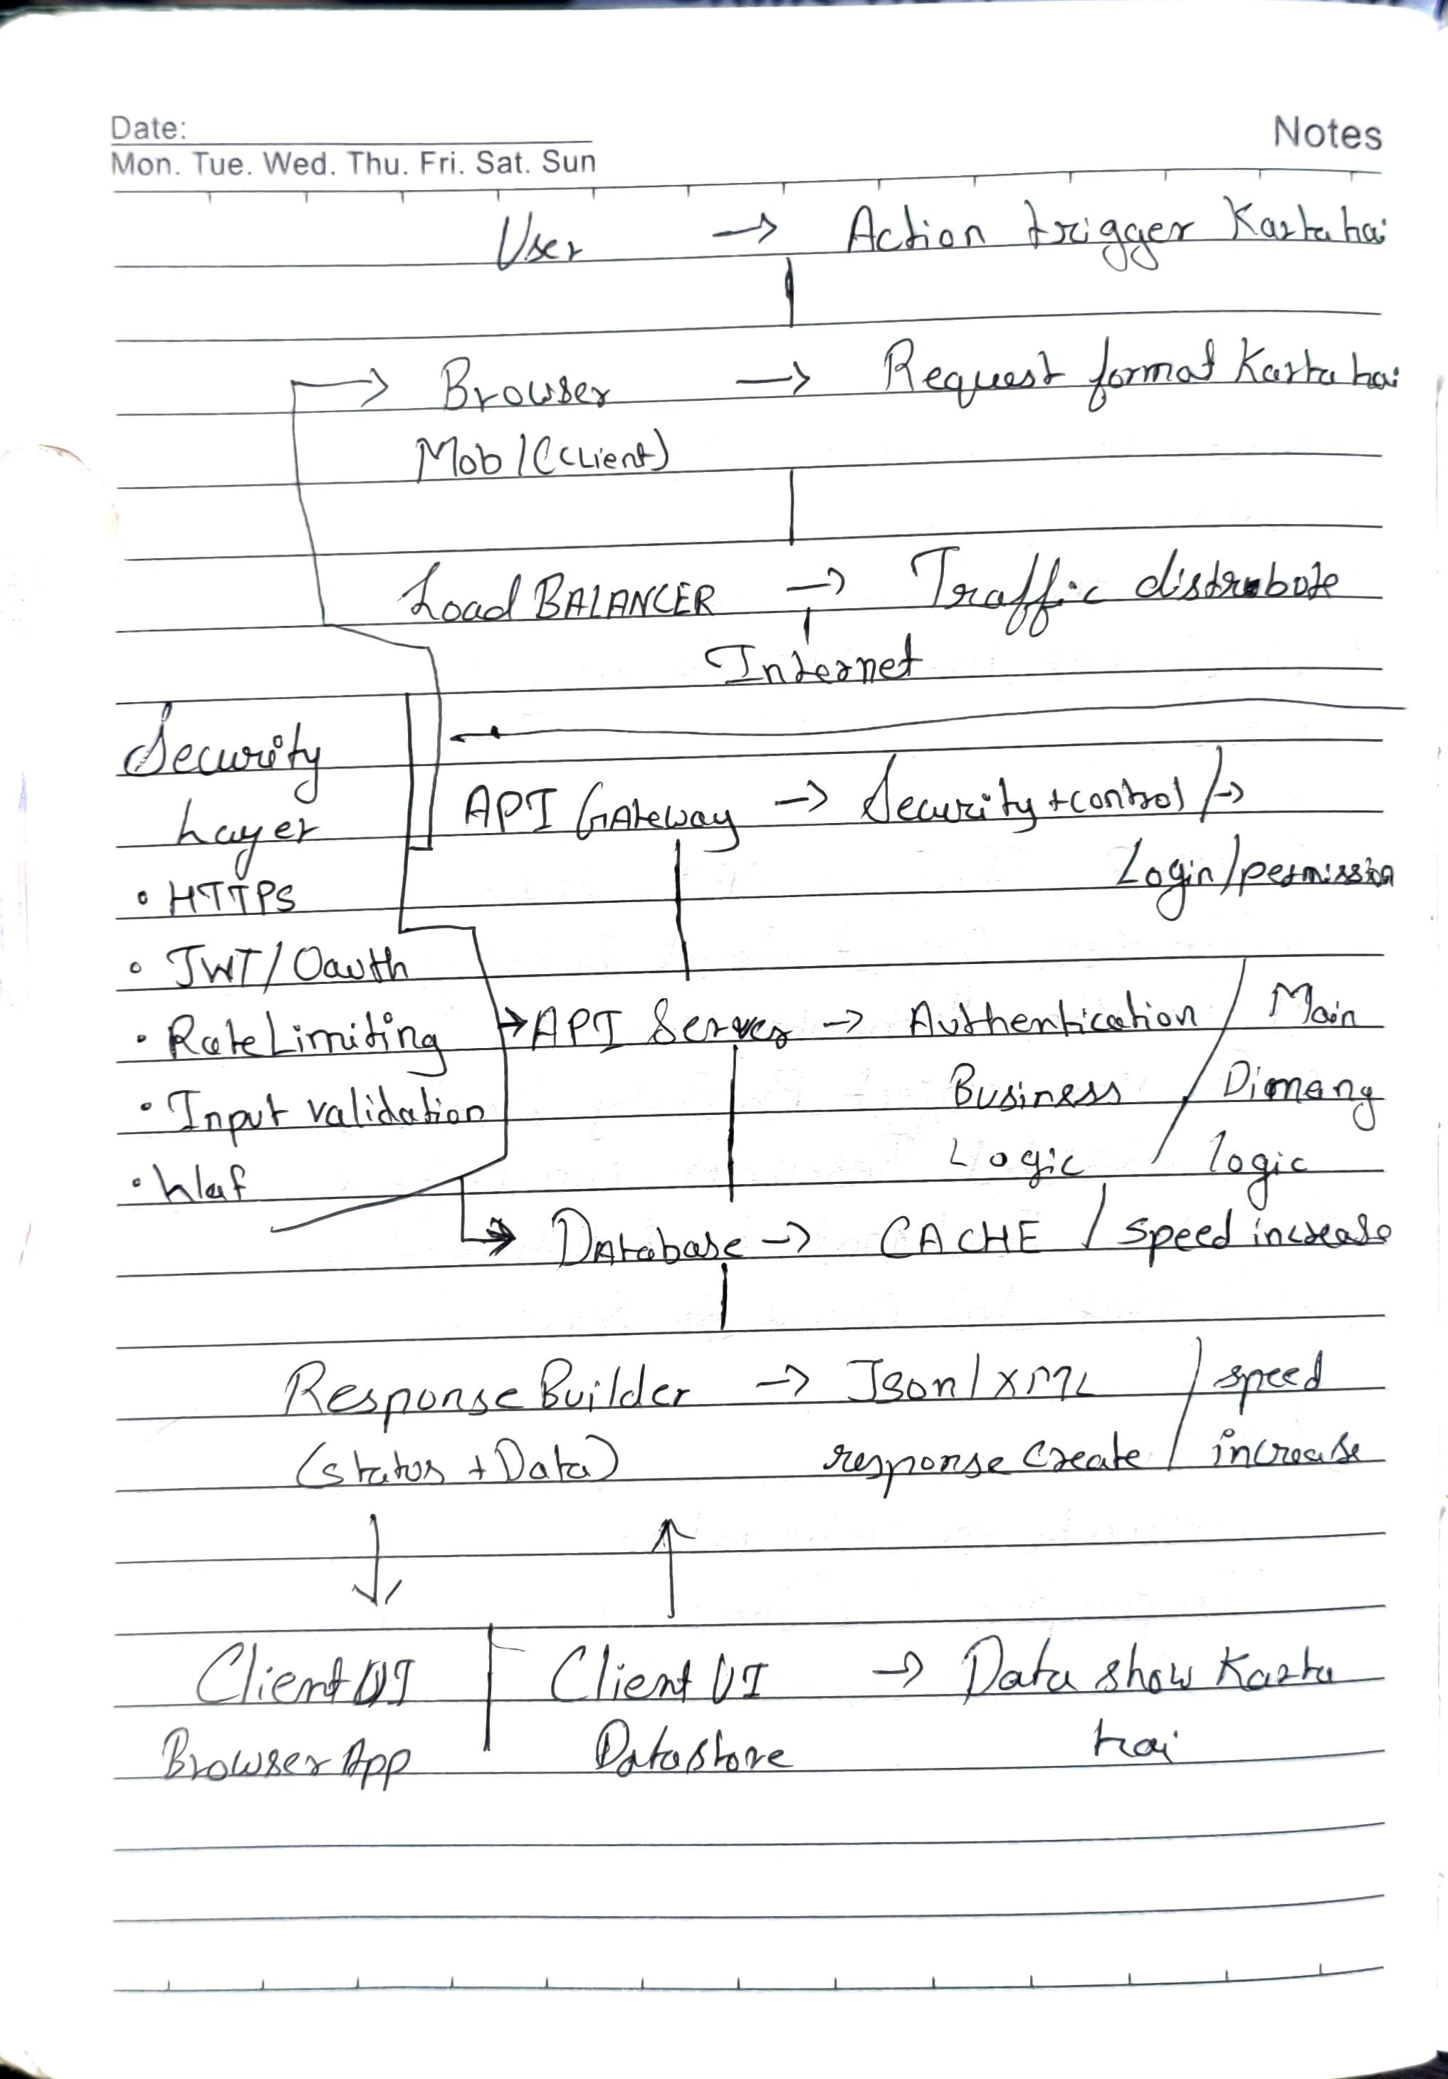
Remediation: 1. Remove 'unsafe-inline' and 'unsafe-eval' from script-src.
2. Use CSP nonce or hashes for inline scripts.
3. Avoid wildcard sources (*) in directives.
Reference: https://cheatsheetseries.owasp.org/cheatsheets/Content_Security_Policy_Cheat_Sheet.html

5. Web OWASP Top 10
OWASP Top 10-2025 | Performed
A01:2025 - Broken Access Control | ✓
A02:2025 - Security Misconfiguration | ✓
A03:2025 - Software Supply Chain Failures | N/A
A04:2025 - Cryptographic Failures | ✓
A05:2025 - Injection | ✓
A06:2025 - Insecure Design | ✓
A07:2025 - Authentication Failures | N/A
A08:2025 - Software or Data Integrity Failures | N/A
A09:2025 - Security Logging and Alerting Failures | N/A
A10:2025 - Mishandling of Exceptional Conditions | ✓

6. Appendix
Appendix section - Non-vulnerable test cases

